Date: 07.02.2025
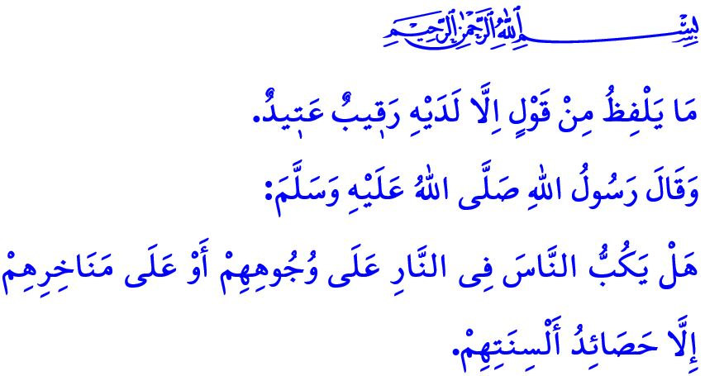
THE TONGUE: A PERSON’S GATEWAY TO EITHER PARADISE OR HELL
Dear Muslims!
One day, the Prophet Muhammad (saw) said to Mu‘adh ibn Jabal, one of the honorable Companions, “Shall I tell you what perfects and completes your religion?” He then held his blessed tongue with his hand and said, “Restrain this.” Upon hearing this, Mu‘adh asked, “O Messenger of Allah! Will we also be held accountable for what we say?” The Messenger of Allah (saw) gave a response that concerns all of us deeply: “Is it not what people earn with their tongues that drags them into Hell?”
Dear Believers!
The tongue is a great blessing granted by Allah the Almighty and at the same time a heavy test. It is the mirror of the mind and the interpreter of the heart. What resides in our hearts is revealed through it. Our thoughts and emotions take form through it. Though small in size, the good and evil it produces are immense. Indeed, the words spoken by the tongue can lead a person either to Paradise or to Hell. There are words that build warm homes and lead to peace and happiness. Yet there are also words that destroy homes and inflict deep, lasting wounds. Some words build bridges between hearts, bringing a smile to an orphan’s face or relief to someone in need. But there are also words that burn like afflictions, causing sleepless nights. Some words provide comfort to hearts that have lost hope and save lives from the captivity of harmful habits. Conversely, there are words that drag a person into sin, depriving them of Allah’s mercy and compassion. As the poet says:
“A word can end a war, a word can cost a life.
A word can turn poisoned food into honey and butter.”
Esteemed Muslims!
Just as the tongue has virtues, it also has evils. Denying the existence and oneness of Allah and falling into shirk, abandoning truth and resorting to lies are among the gravest evils of the tongue. Slandering an innocent person, wasting our limited breaths through gossip, and sowing discord by talebearing are signs of the tongue’s moral collapse. Insulting or attacking someone’s dignity and honor, even in jest, is a corruption of the tongue. The Prophet Muhammad (saw) commanded us to restrain our speech by saying: مَنْ كَانَ يُؤْمِنُ بِا للّٰهِ وَالْيَوْمِ الْآخِرِ فَلْيَقُلْ خَيْرًا أَوْ لِيَصْمُتْ “Whoever believes in Allah and the Last Day should talk what is good or keep quiet”
Esteemed Believers!
The evils of the tongue are not limited to real life. The tongue can lead to numerous sins and prohibitions on digital platforms as well. Just as lying, slander, mockery, and profane speech are haram in real life, they are equally sinful in virtual environments. Any word that casts suspicion on others, marginalizes them, targets them, or injures their dignity and honor is a violation of people’s rights both in real life and online. Sharing information that we are not certain of is a grave sin in social life, and the same applies to sharing it on digital platforms. Worse still is spreading false news to incite people, disrupt societal peace, or undermine the unity and solidarity of our nation. This is an obvious act of discord and a major sin.
Dear Muslims!
In the verse I recited at the beginning of this khutbah, Allah the Almighty says: “Not a word does a person utter without having a ˹vigilant˺ observer ready ˹to write it down˺.” Therefore, let us be mindful of every word that comes from our mouths. Let us avoid any speech that severs the bonds of love and affection among people or causes hatred and enmity. In all areas of life—within our families, in our relationships with neighbors and relatives, at work, and on the road—let us ensure that our words do not harm anyone. Let us strive to be Muslims from whose hands and tongues others feel safe. Let us reflect the beauty of Islam in our language. Let the Prophet Muhammad’s (saw) teaching, اَلْكَلِمَةُ الطَّيِّبَةُ صَدَقَةٌ “A good word is sadaqah,” be our guiding principle. May our words revive hearts, bring joy to souls, and grant peace to troubled minds.
Dear Muslims!
Next Thursday evening, we will, inshallah, observe the Laylat al-Bara’ah. Let us dedicate this sacred night to seeking forgiveness for our sins, healing the hearts we have hurt, ending disputes, and striving for our eternal salvation. May this Laylat al-Bara’ah be blessed in advance. I pray to Allah the Almighty that this night brings goodness, peace, and blessings to you, my esteemed congregation, to our honorable nation, to the Muslim world, and to all of humanity.

Tirmidhi, Iman, 8.
Bukhari, Riqaq, 23;
Qaf, 50/18.
Bukhari, Jihad, 128. General Directorate of Religious Services

